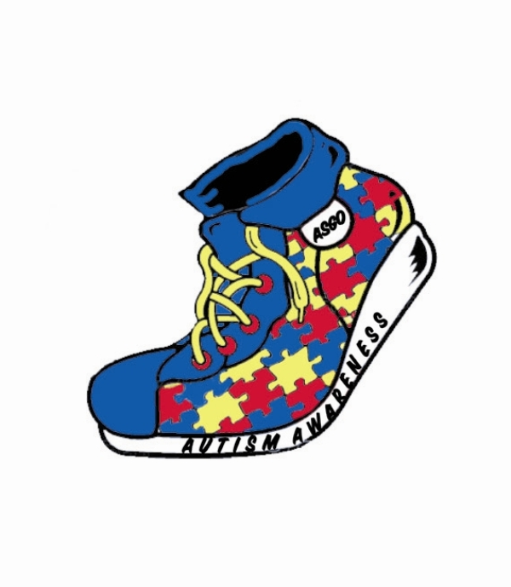

**The Autism Society of Greater Orlando’s**

**20th Annual Autism Family Fun Day**

**Sponsorship Information**

The Autism Society of Greater Orlando is pleased to announce it will be holding its 20th Annual Autism Family Fun Day on Saturday, April 19, 2025, inside the Orange County Convention Center’s **North Concourse** from 8:00 AM – 12:00 PM. Sponsorships are now being accepted to make this event a success.

The Autism Society of Greater Orlando is a 501(c)(3) not for profit organization. The mission of ASGO is that all individuals within the autism spectrum will be provided a lifetime network of opportunities to become fully accepted, included, and actively participating members of our community, through family support, education, advocacy, and public awareness. To achieve this goal, ASGO is sponsoring an autism walk. **100% of the proceeds from this event will stay right here in Central Florida to support our families affected by autism.** You can read more about autism and ASGO by visiting our website at www.asgo.org.

Sponsorships with corporate benefits are outlined on the attached sheet. Please take a few minutes to review the breakdown of sponsorships and see how your business would benefit from a partnership with ASGO. The deadline for inclusion on the t-shirt and sponsorship board is February 28, 2025.

If you have any questions, please don’t hesitate to contact the ASGO office at 407-855-0235. Thanks in advance for your consideration.

Sincerely,

Donna Lorman

Donna Lorman

President

Autism Society of Greater Orlando

1650 Sand Lake Road Suite 240

Orlando, FL 32809

407-855-0235 – phone 407-855-5129 - fax

www.asgo.org

501(c) (3) – Not for profit organization

**ASGO’s 20th Annual Autism Family Fun Day**

**Sponsorship Levels**

**Title Sponsor - $5,000**

* Large Black & White Logo on back of T-shirt
* Large Color Logo on the Event Board
* Large Vendor Booth (2 tables & 2 Chairs) with **Premium Placement**
* On Stage Presence with Opportunity to Speak during Opening Ceremonies
* Presentation of Large Puzzle Piece Plaque during Opening Ceremonies
* Admission for 100 participants at the Event (includes t-shirts)
* 12 Month ASGO Membership
* Acknowledgement on ASGO Website **with link to your business website**
* Unlimited postings on our ASGO social media platforms (sponsor must provide material)
* Top placement on our Preferred Business Referral List

**High Top - $2,500:**

* Small Black & White Logo on back of T-shirt
* Large Color Logo on the Event Board
* Large Vendor Booth (2 tables & 2 Chairs) with **Premium Placement**
* Presentation of Large Puzzle Piece Plaque during Opening Ceremonies
* Admission for up to 75 participants at the Event (includes t-shirts)
* 12 Month ASGO Membership
* Acknowledgement on ASGO Website
* Monthly postings on our ASGO social media platforms (sponsor must provide material)
* Second placement on our Preferred Business Referral List

**Pump - $1,000:**

* Company Name on back of Event T-shirt
* Small Color Logo on Event Board
* Small Vendor Booth (1 table & 1 Chair) with **Premium Placement**
* Presentation of Small Puzzle Piece Plaque during event
* Admission for up to 30 participants at the Event (includes t-shirts)
* Acknowledgement on ASGO Website
* Quarterly postings on our ASGO social media platforms (sponsor must provide material)
* Third placement on our Preferred Business Referral List

**Sneaker - $500**

* Name on Sponsorship Board
* Small Vendor Booth (1 table & 1 Chair) in **High Traffic Area**
* Certificate of Appreciation provided
* Admission for up to 10 participants (includes t-shirts)
* Acknowledgement on ASGO Website
* One time posting on our ASGO social media platforms (sponsor must provide material)
* Fourth placement on our Preferred Business Referral List

**Vendor - $300**

* Name on Vendor Booth Sponsorship Board
* Small Vendor Booth (1 table & 1 Chair) along event path
* 2 Participants (t-shirts not included)
* Listing on our Preferred Business Referral List

**ASGO’s 20th Annual Autism Family Fun Day**

**Sponsorship Form**

Our company would love to help sponsor ASGO’s Autism Family Fun Day at the following level:

___ Title - $5,000

___ High Top - $2,500

___ Pump - $1,000

___ Sneaker - $500

___ Vendor - $300

__ ***Additional Participants or T-shirts Over Number Included in Sponsorship @ $10.00 each (add to total)***

Business Name: _________________________________________________

Business Address: _______________________________________________

Contact name: ___________________________________________________

Phone number: __________________________________________________

E-mail address: __________________________________________________

Vendor Booth Responses:

___ Yes, we will use a vendor booth

___ No, we will not be using a vendor booth

Total Number of Participants: ____ *(****please submit names of all participants for check in area****)*

Shirt Sizes (*include number of shirts per size – Deadline is 2/28/2025 - Shirts are not guanteed after that date)*

___ AS ___ AM ___ AL ___ XL ___ XXL ___ XXXL (**Shirts not included for vendor level**)

**Payment:**

Check: Please make payable to ASGO Check *#________* Credit Card q Visa q MasterCard

Credit Card# _______________________________ v-code# _______ Exp. Date ______/______ Zip: ________

Card Holder Name ______________________________ Signature__________________________